These are the connectors we are using to connect the old harness to the new alternator:
On wires B+ going to the alt we put the connectors 2), 1 on each wire. These are secured with a brass M6 nut.
On wire D+ going to the alt we put the connector 1). This is secured with a brass M5 nut.

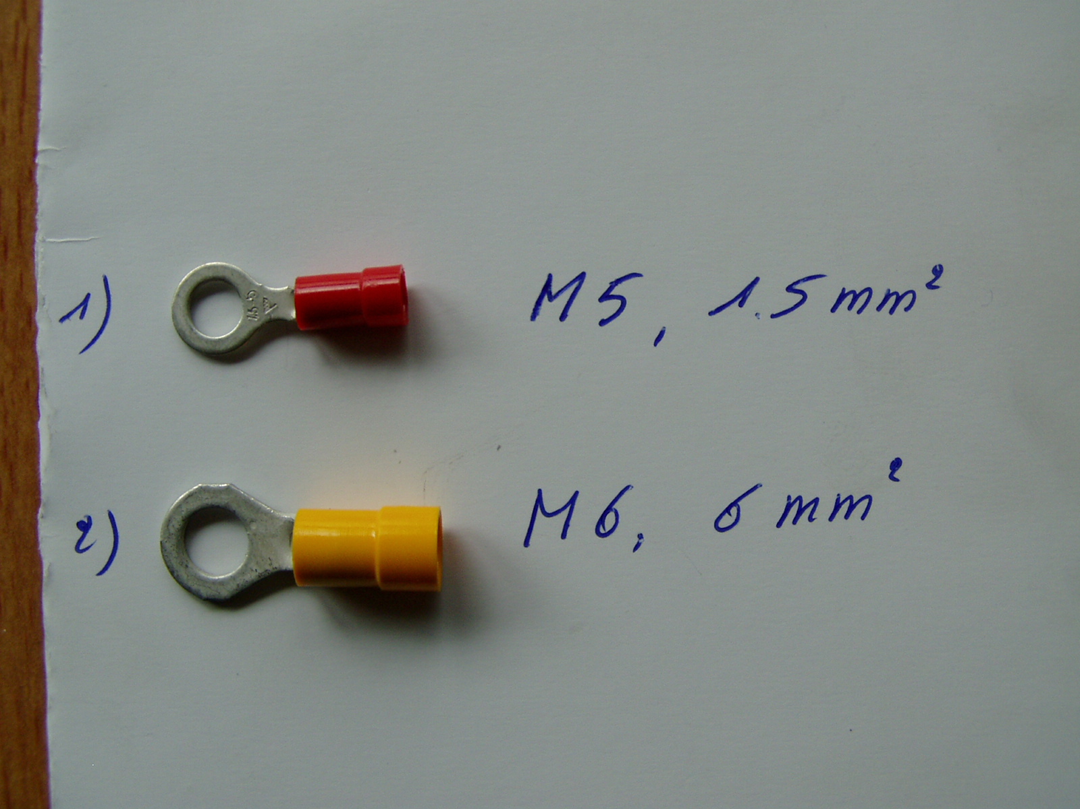

The wire W+, for the rpm-reading already has a ring-connector, secured with a brass M5 nut.
Item 35 on the fax is the same as 1) on the picture.
Item 42 on the fax is:
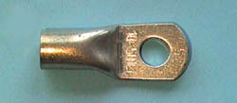
So basically the same, M6 hole, but not isolated (they probably put on heat shrink), and they use 1 to put both B+ wires in.

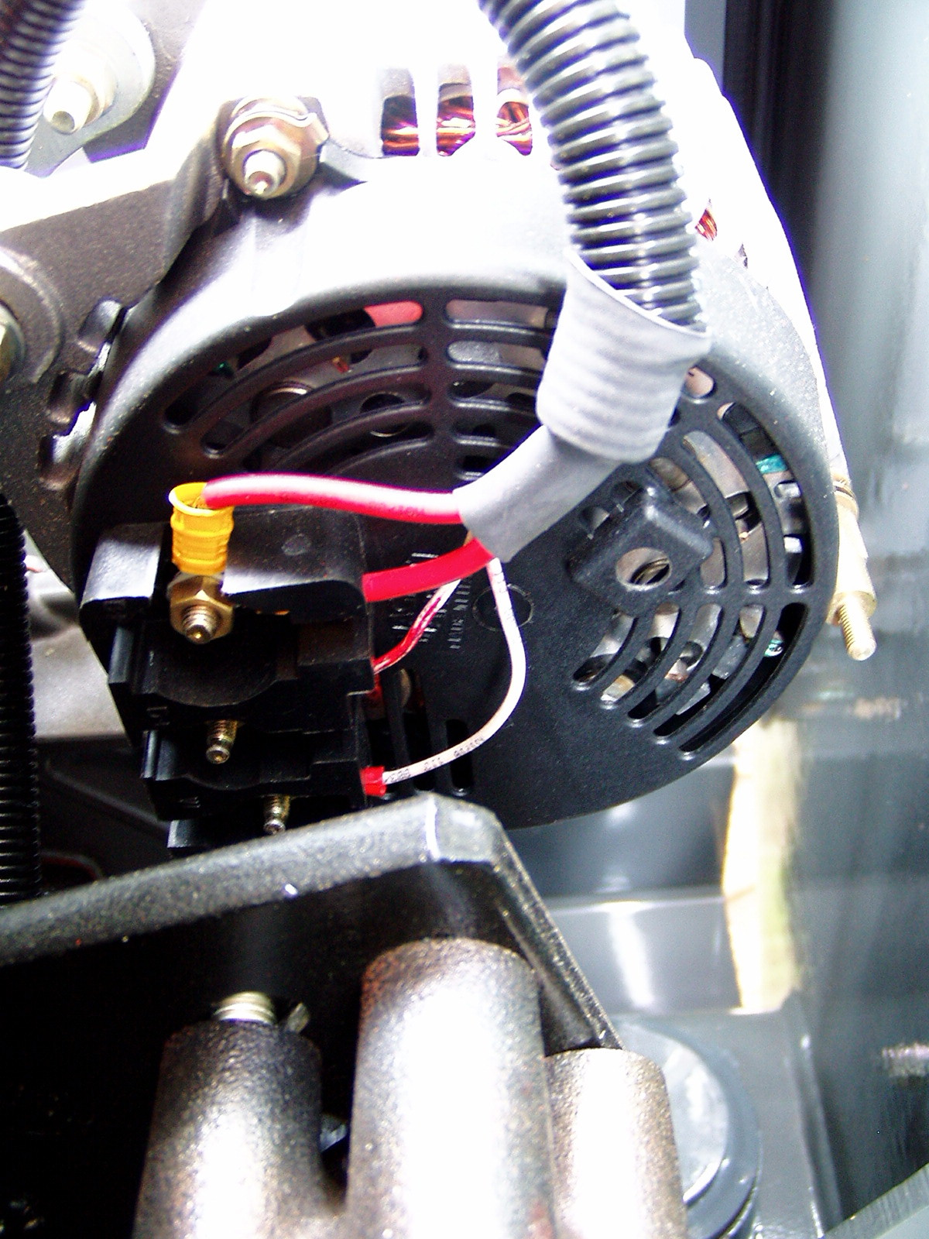
B+
D+
W

